## ***SUPER STORE DASHBORD***

**KPI**

## ***TOTAL REVENUE***

select SUM(Sales) as "total revenue" from dbo.[SuperStoreUS-2015]

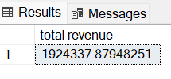

## ***TOTAL ORDER***

select COUNT(distinct Order_ID)as "total order" from dbo.[SuperStoreUS-2015]

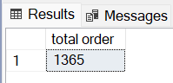

## ***TOTAL QUANTITY***

select SUM(Quantity_ordered_new) as "total quantity" from dbo.[SuperStoreUS-2015]

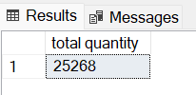

## ***TOTAL PROFIT***

select SUM(Profit) "total profit" from dbo.[SuperStoreUS-2015]

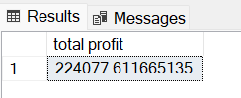

## ***AVERAGE ORDER VALUE***

select sum(Quantity_ordered_new)/COUNT(distinct Order_ID) as "average order value" from dbo.[SuperStoreUS-2015]

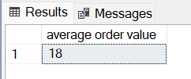

## ***HIGHEST SELLING MONTH***

select top 1 DATENAME(month,Order_Date) as "month name",sum(Sales) as "total sale" from dbo.[SuperStoreUS-2015]

group by DATENAME(month,Order_Date)

order by sum(Sales) desc

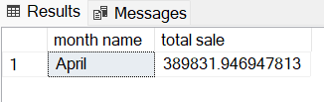

## ***WORST SELLING MONTH***

select top 1 DATENAME(month,Order_Date) as "month name",sum(Sales) as "total sale" from dbo.[SuperStoreUS-2015]

group by DATENAME(month,Order_Date)

order by sum(Sales)

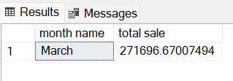

## ***HIGHEST PROFIT MONTH***

select top 1 DATENAME(month,Order_Date) as "month name",sum(Profit) as "total profit" from dbo.[SuperStoreUS-2015]

group by DATENAME(month,Order_Date)

order by sum(Profit) desc

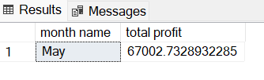

## ***WORST PROFIT MONTH***

select top 1 DATENAME(month,Order_Date) as "month name",sum(Profit) as "total profit" from dbo.[SuperStoreUS-2015]

group by DATENAME(month,Order_Date)

order by sum(Profit)

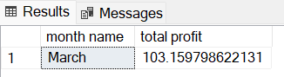

## ***HIGHEST PROFIT BY REGION***

select top 1 Region as "region",sum(Profit) as "total profit" from dbo.[SuperStoreUS-2015]

group by Region

order by sum(Profit) desc

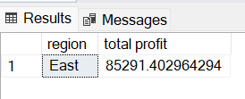

## ***WORST PROFIT BY REGION***

select top 1 Region as "region",sum(Profit) as "total profit" from dbo.[SuperStoreUS-2015]

group by Region

order by sum(Profit)

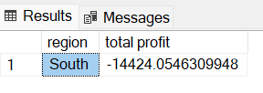

## ***HIGHEST SALES BY REGION***

select top 1 Region as "region",sum(Sales) as "total sale" from dbo.[SuperStoreUS-2015]

group by Region

order by sum(Sales) DESC

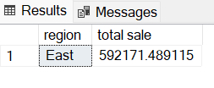

## ***WORST SALES BY REGION***

select top 1 Region as "region",sum(Sales) as "total sale" from dbo.[SuperStoreUS-2015]

group by Region

order by sum(Sales)

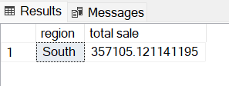

## ***HIGHEST SELLING DAY***

select top 1 DATENAME(DAY,Order_Date) as "day",sum(Sales) as "total sale" from dbo.[SuperStoreUS-2015]

group by DATENAME(DAY,order_date)

order by sum(Sales) desc

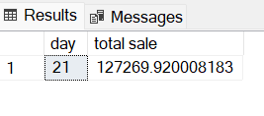

## ***WORST SELLING DAY***

select top 1 DATENAME(DAY,Order_Date) as "day",sum(Sales) as "total sale" from dbo.[SuperStoreUS-2015]

group by DATENAME(DAY,order_date)

order by sum(Sales)

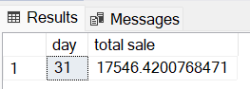

## ***HIGHEST PROFIT DAY***

select top 1 DATENAME(DAY,Order_Date) as "day",sum(profit) as "total sale" from dbo.[SuperStoreUS-2015]

group by DATENAME(DAY,order_date)

order by sum(Profit) desc

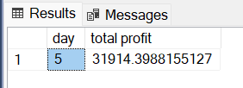

## ***WORST PROFIT DAY***

select top 1 DATENAME(DAY,Order_Date) as "day",sum(profit) as "total sale" from dbo.[SuperStoreUS-2015]

group by DATENAME(DAY,order_date)

order by sum(Profit)

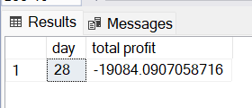



***HIGHEST 5 SELLING DAY***

select top 5 DATENAME(DAY,Order_Date) as "day",sum(Sales) as "total sale" from dbo.[SuperStoreUS-2015]

group by DATENAME(DAY,order_date)

order by sum(Sales) desc

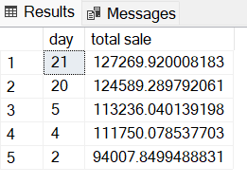

***WORST 5 SELLING DAY***

select top 5 DATENAME(DAY,Order_Date) as "day",sum(Sales) as "total sale" from dbo.[SuperStoreUS-2015]

group by DATENAME(DAY,order_date)

order by sum(Sales)

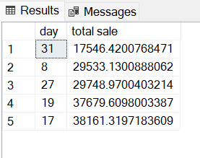

***HIGHEST 5 PROFIT DAY***

select top 5 DATENAME(DAY,Order_Date) as "day",sum(profit) as "total profit" from dbo.[SuperStoreUS-2015]

group by DATENAME(DAY,order_date)

order by sum(Profit) desc

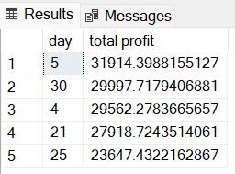

***WORST 5 PROFIT DAY***

select top 5 DATENAME(DAY,Order_Date) as "day",sum(profit) as "total profit" from dbo.[SuperStoreUS-2015]

group by DATENAME(DAY,order_date)

order by sum(Profit)

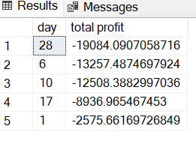

***HIGHEST 5 ORDER DAY***

select top 5 DATENAME(DAY,Order_Date) as "day",COUNT(distinct Order_ID) as "total order" from dbo.[SuperStoreUS-2015]

group by DATENAME(DAY,order_date)

order by [total order] DESC

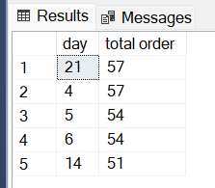

***WORST 5 ORDER DAY***

select top 5 DATENAME(DAY,Order_Date) as "day",COUNT(distinct Order_ID) as "total order" from dbo.[SuperStoreUS-2015]

group by DATENAME(DAY,order_date)

order by [total order]

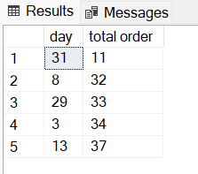



***HIGHEST 5 SELLING PRODUCT NAME***

select top 5 Product_Name as "PRODUCT NAME",sum(Sales) as "TOTAL SALE" from dbo.[SuperStoreUS-2015]

group by Product_Name

order by sum(Sales) desc

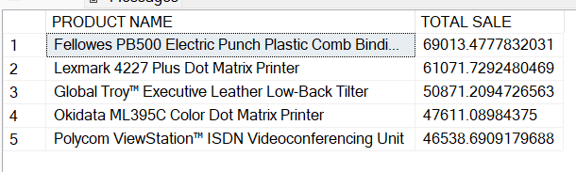

***WORST 5 SELLING PRODUCT NAME***

select top 5 Product_Name as "PRODUCT NAME",sum(Sales) as "TOTAL SALE" from dbo.[SuperStoreUS-2015]

group by Product_Name

order by sum(Sales)

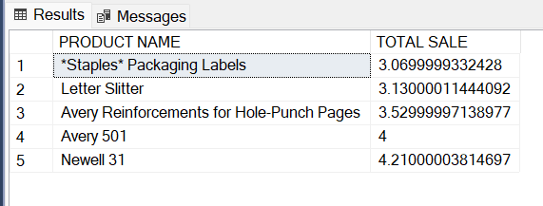

***HIGHEST 5 PROFIT PRODUCT NAME***

select top 5 Product_Name as "PRODUCT NAME",sum(Profit) as "TOTAL profit" from dbo.[SuperStoreUS-2015]

group by Product_Name

order by sum(Profit) DESC

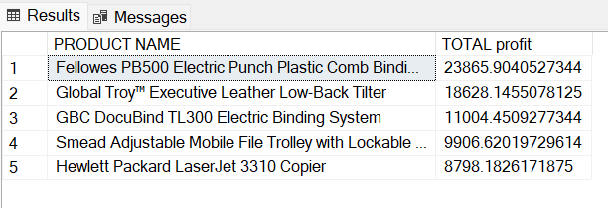

***WORST 5 PROFIT PRODUCT NAME***

select top 5 Product_Name as "PRODUCT NAME",sum(Profit) as "TOTAL profit" from dbo.[SuperStoreUS-2015]

group by Product_Name

order by sum(Profit)

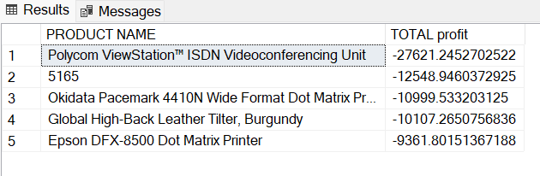

***HIGHEST 5 QUANTITY SALE PRODUCT NAME***

select top 5 Product_Name as "PRODUCT NAME",sum(Quantity_ordered_new) as "TOTAL QUANTITY" from dbo.[SuperStoreUS-2015]

group by Product_Name

order by sum(Quantity_ordered_new) DESC

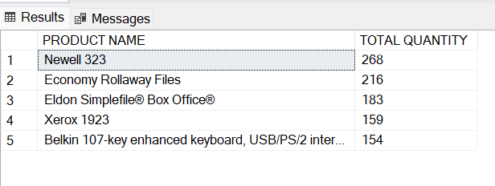

***WORST 5 QUANTITY SALE PRODUCT NAME***

select top 5 Product_Name as "PRODUCT NAME",sum(Quantity_ordered_new) as "TOTAL QUANTITY" from dbo.[SuperStoreUS-2015]

group by Product_Name

order by sum(Quantity_ordered_new)

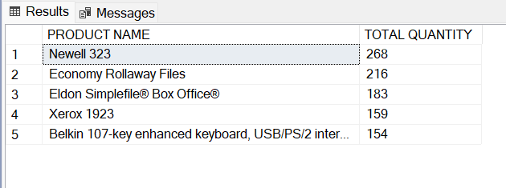



***MONTHLY WITH SALE***

select DATENAME(MONTH,Order_Date) as "MONTHS",sum(Sales) as "TOTAL SALE" from dbo.[SuperStoreUS-2015]

group by DATENAME(MONTH,Order_Date)

order by sum(Sales) desc

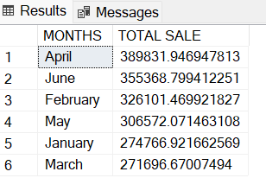

***MONTHLY WITH PROFIT***

select DATENAME(MONTH,Order_Date) as "MONTHS",sum(Profit) as "TOTAL PROFIT" from dbo.[SuperStoreUS-2015]

group by DATENAME(MONTH,Order_Date)

order by sum(Profit) desc

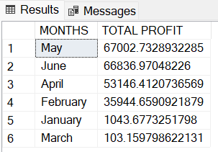

***DAILY WITH SALE***

select DATENAME(DAY,Order_Date) as "DAYS",sum(Sales) as "TOTAL SALE" from dbo.[SuperStoreUS-2015]

group by DATENAME(DAY,Order_Date)

order by sum(Sales) desc

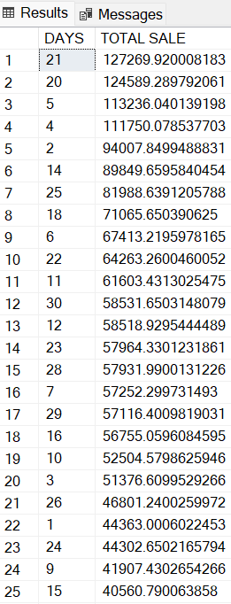 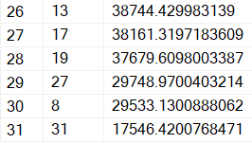

***DAILY WITH PROFIT***

select DATENAME(DAY,Order_Date) as "DAYS",sum(Profit) as "TOTAL PROFIT" from dbo.[SuperStoreUS-2015]

group by DATENAME(DAY,Order_Date)

order by sum(Profit) desc

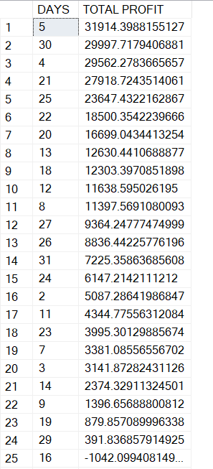

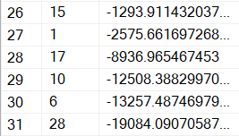

***WEEKLY WITH SALE***

select DATENAME(WEEKDAY,Order_Date) as "WEEK",sum(Sales) as "TOTAL SALE" from dbo.[SuperStoreUS-2015]

group by DATENAME(WEEKDAY,Order_Date)

order by sum(Sales) desc

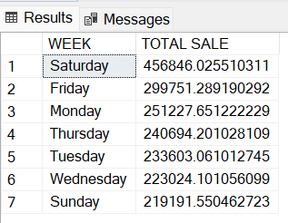

***WEEKLY WITH PROFIT***

select DATENAME(WEEKDAY,Order_Date) as "WEEKS",sum(Profit) as "TOTAL PROFIT" from dbo.[SuperStoreUS-2015]

group by DATENAME(WEEKDAY,Order_Date)

order by sum(Profit) desc

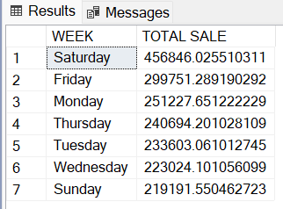



***CATEGORY BY SELLING***   
SELECT Product_Category as "category",SUM(Sales) AS "SALES" from dbo.[SuperStoreUS-2015]

group by Product_Category

order by sum(sales) desc

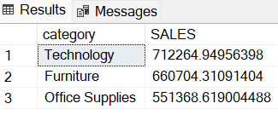

***CATEGORY BY PROFIT***

SELECT Product_Category as "category",SUM(Profit) AS "PROFIT" from dbo.[SuperStoreUS-2015]

group by Product_Category

order by sum(Profit) desc

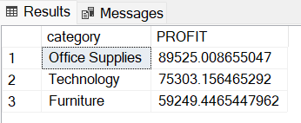

***CATEGORY BY ORDER***

SELECT Product_Category as "category",COUNT(DISTINCT Order_ID) AS "order" from dbo.[SuperStoreUS-2015]

group by Product_Category

order by COUNT(distinct Order_ID) desc

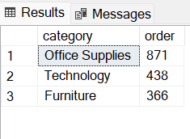

***CATEGORY BY QUANTITY***

SELECT Product_Category as "category",SUM(Quantity_ordered_new) AS "QUANTITY" from dbo.[SuperStoreUS-2015]

group by Product_Category

order by SUM(Quantity_ordered_new) desc

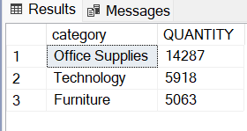

***SEGMENT BY SELLING***

SELECT Customer_Segment as "category",SUM(Sales) AS "SALES" from dbo.[SuperStoreUS-2015]

group by Customer_Segment

order by sum(sales) desc

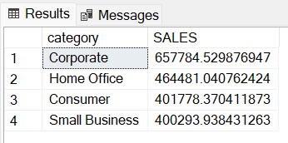

***SEGMENT BY PROFIT***

SELECT Customer_Segment as "category",SUM(Profit) AS "PROFIT" from dbo.[SuperStoreUS-2015]

group by Customer_Segment

order by sum(Profit) desc

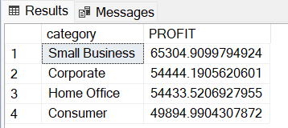

***SEGMENT BY ORDER***

SELECT Customer_Segment as "category",COUNT(DISTINCT Order_ID) AS "ORDER" from dbo.[SuperStoreUS-2015]

group by Customer_Segment

order by COUNT(DISTINCT Order_ID) desc

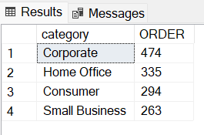

***SEGMENT BY QUANTITY***

SELECT Customer_Segment as "SEGMENT",SUM(Quantity_ordered_new) AS "QUANTITY" from dbo.[SuperStoreUS-2015]

group by Customer_Segment

order by SUM(Quantity_ordered_new) desc

